|  |  |
| --- | --- |
| A picture containing text, library, shelf, book  Description automatically generated  Group Work Report  Library Booking Application | 18/12/21  Conor Clyde  Mobile Application Development |

Table of Contents

1. Introduction to the project 2

a. Problem Statement 2

b. Proposed Solution 2

c. Resources 2

2. Project Plan 3

3. Paper Prototype 5

4. Application Poster 11

5. Design 12

6. Developing a Firebase Realtime Database 13

7. Developing the Application 16

a. Home Page 16

b. Campus Selection Page 19

c. Campus Overview page 21

d. Settings Page 25

e. Reset Password Page 29

f. Splash Screen 31

# Introduction to the project

## Problem Statement

Due to the ongoing COVID-19 pandemic, there has been an increasing number of concerns in regard to overcrowding within the libraries at the various Ulster University campuses.

## Proposed Solution

These concerns can be eased by developing a smart application which will allow students, and various other types of people who use Ulster University’s libraries to book slots within the library facility when it is not at the point of being overcrowded, as well as provide either textual or visual information on how close the library is to becoming overcrowded.

## Resources

Figure 1 shows the resources that I plan to use throughout the project.

|  |  |
| --- | --- |
| **Resource** | **Use** |
| Android Studio | Main Development Environment |
| Microsoft Word/Excel | Creating design documentation |
| Figma | Creating Paper Prototype |
| Mila Note | Creating Application Poster |
| Java | Main programming language |

Figure - Project resources

# Project Plan

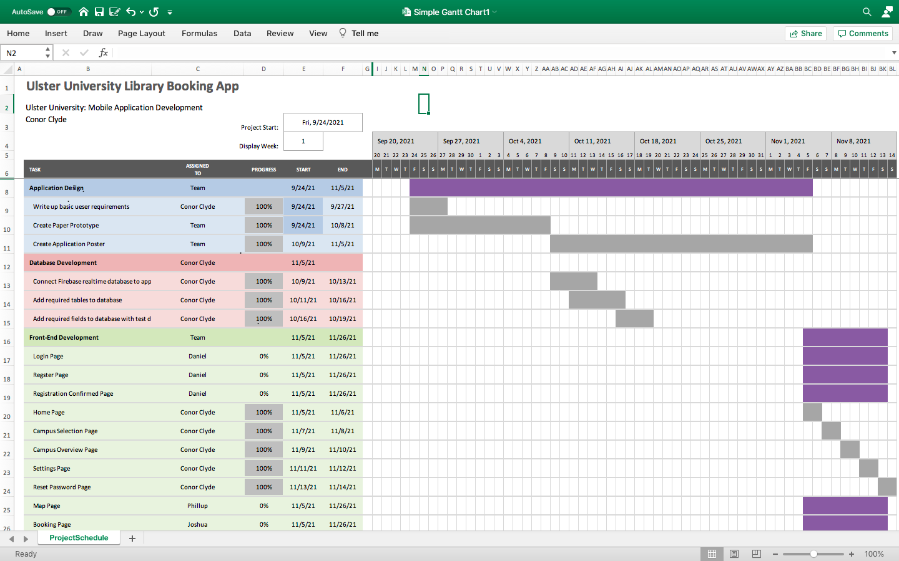Figure 2 shows a project plan which provides a detailed overview of the project, as well as a description of my roles within the project. All tasks that I was individually responsible are indicated by the assigned by Conor Clyde fields, while all tasks that I worked on with my team are indicated by the assigned by team fields.

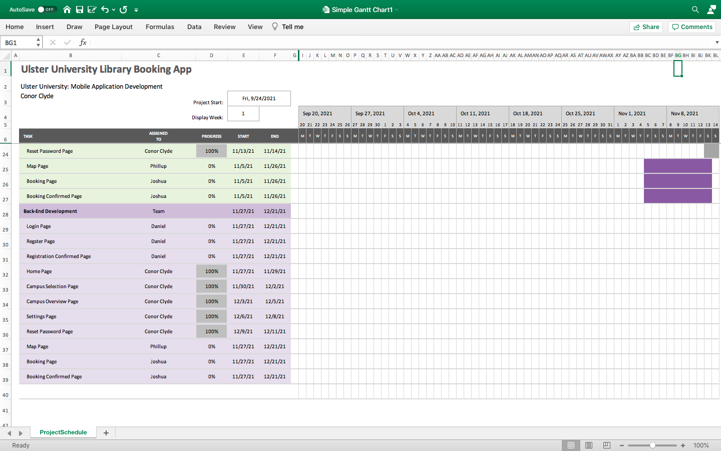

Figure - Project plan

# Paper Prototype

Figure 3 shows screenshots which represent the paper prototype of the application. 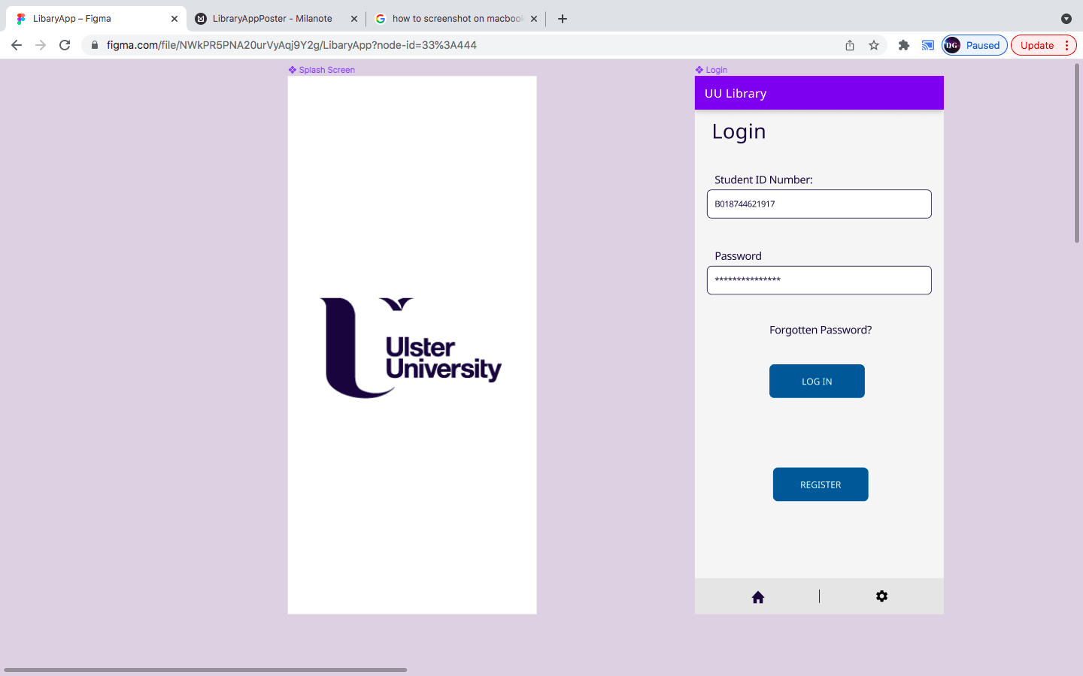

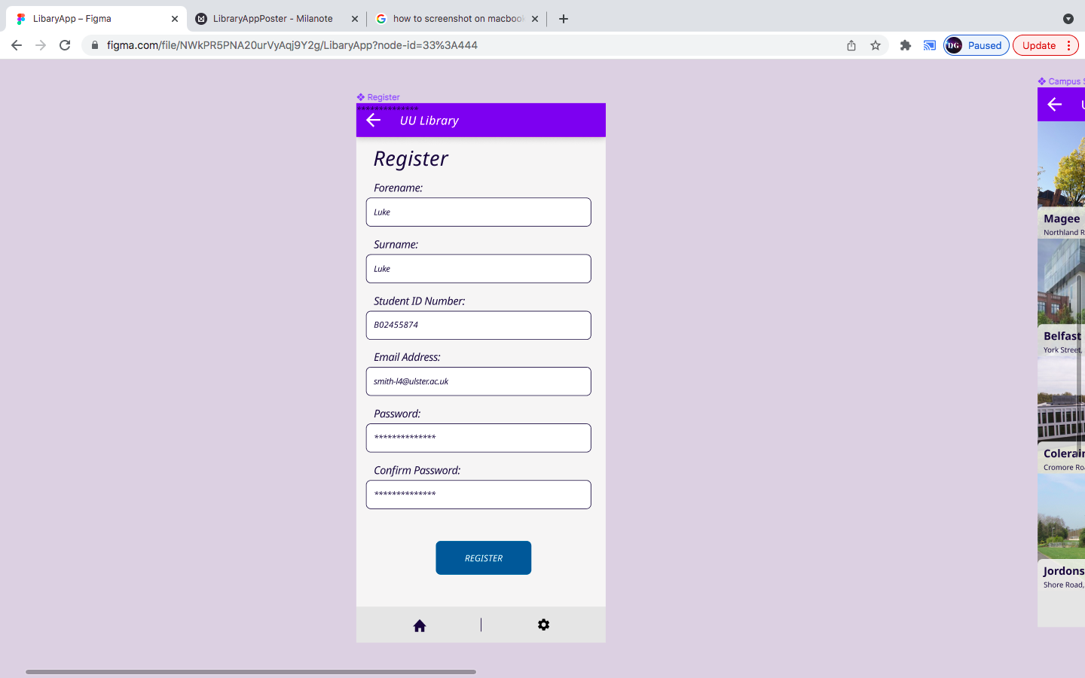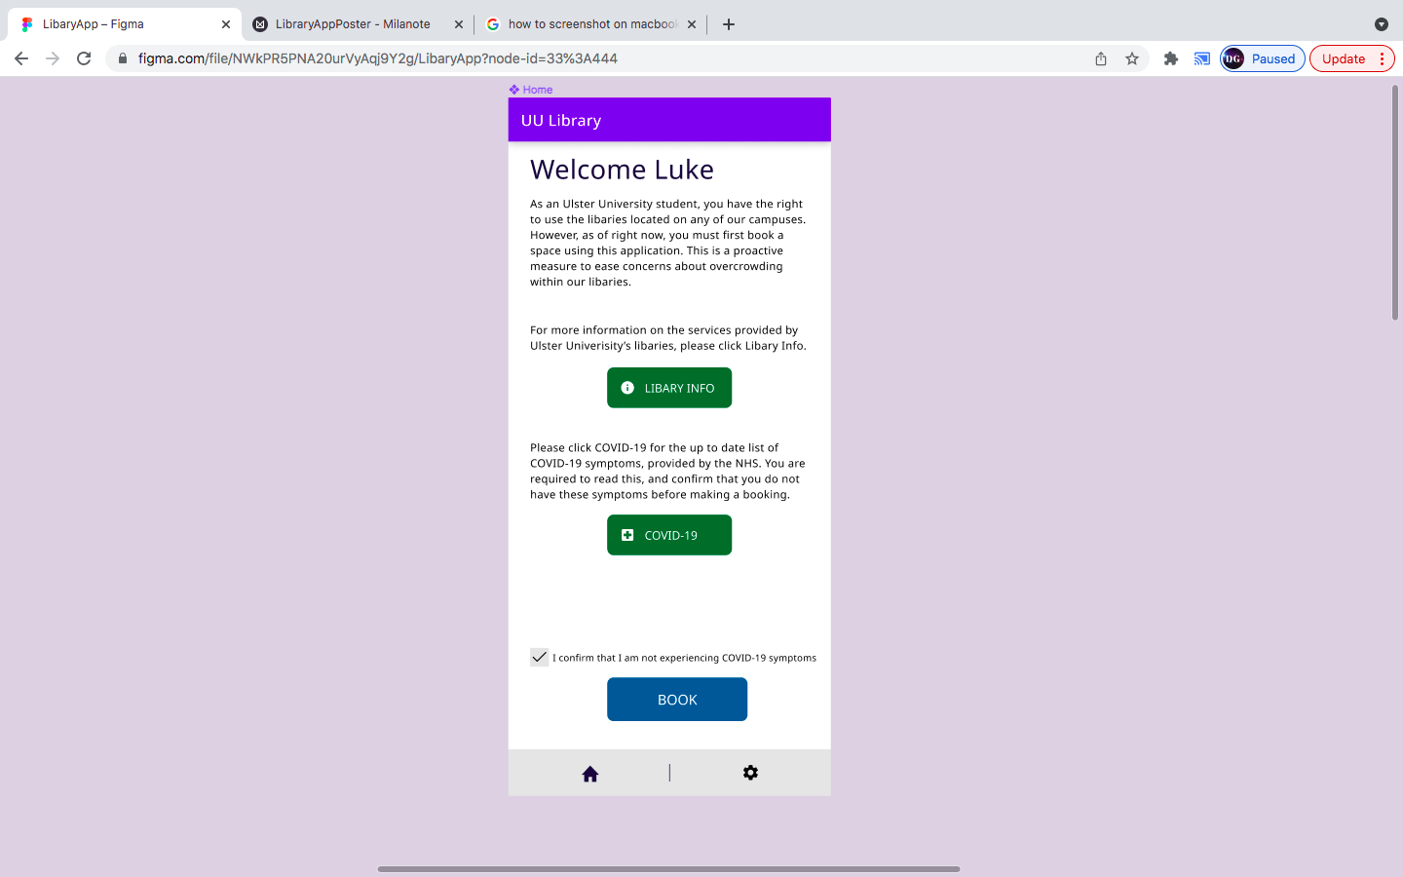

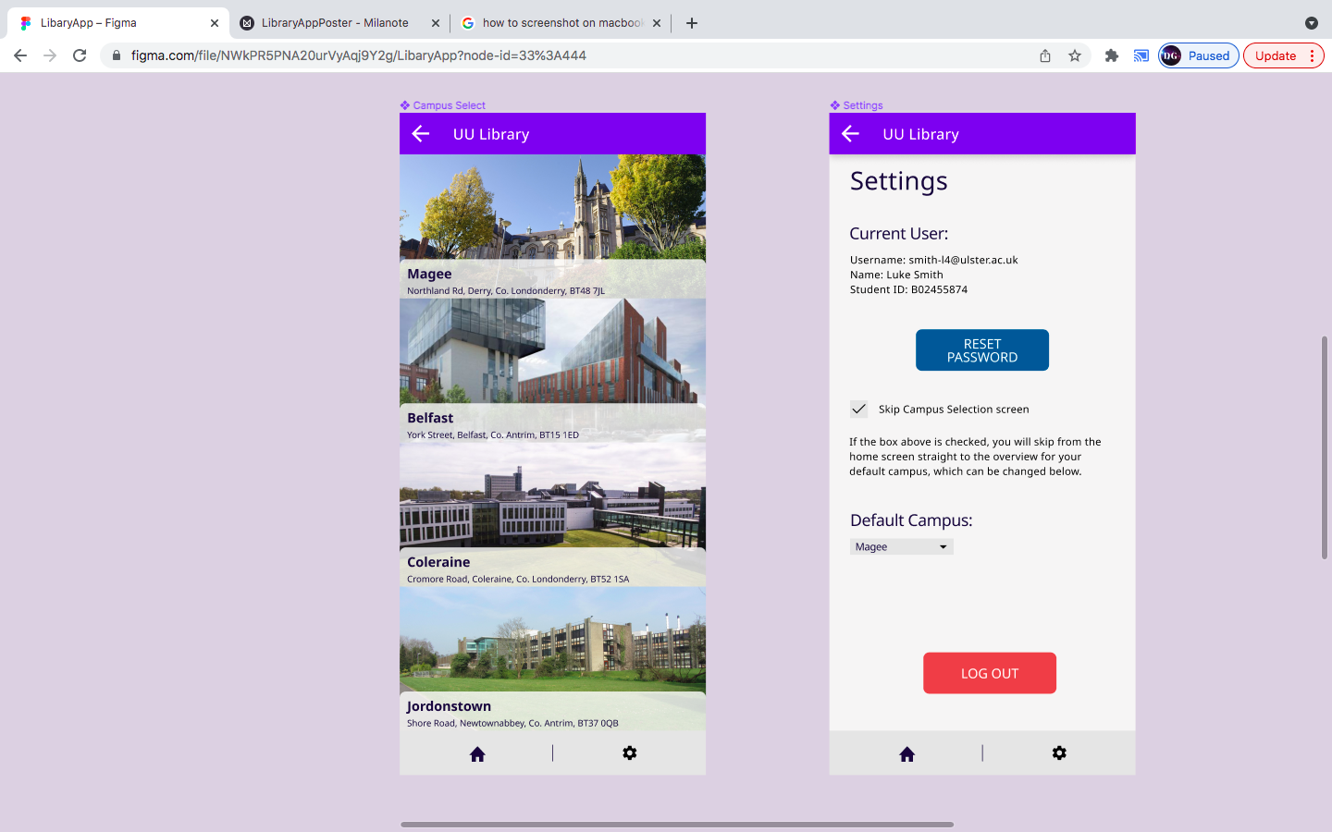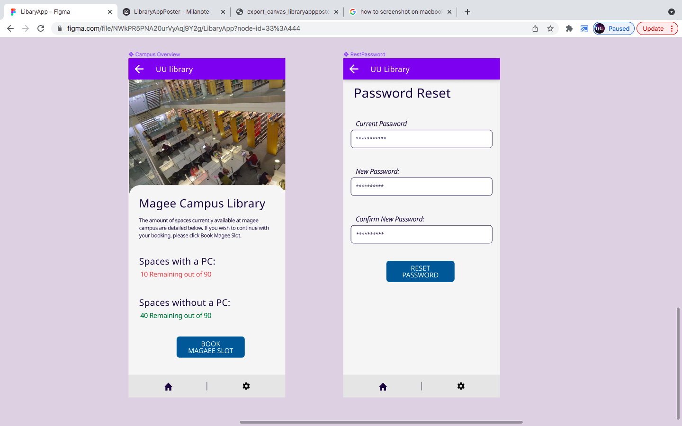



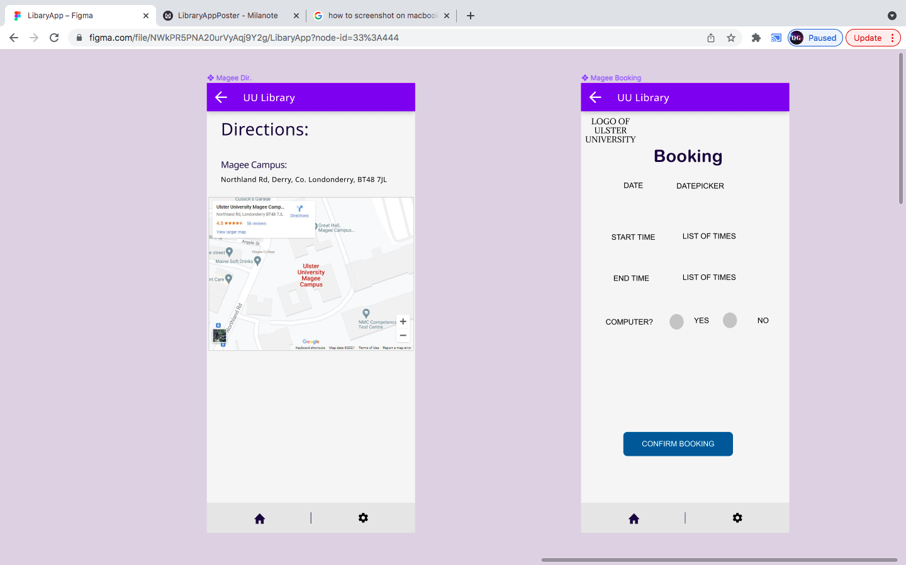

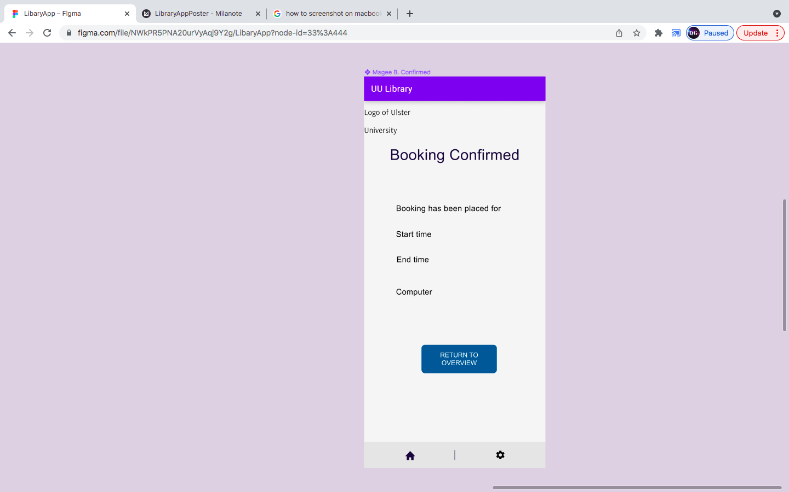

Figure - Paper prototype

# Application Poster

Figure 4 is an application poster which shows an informative summary of the ideal application.

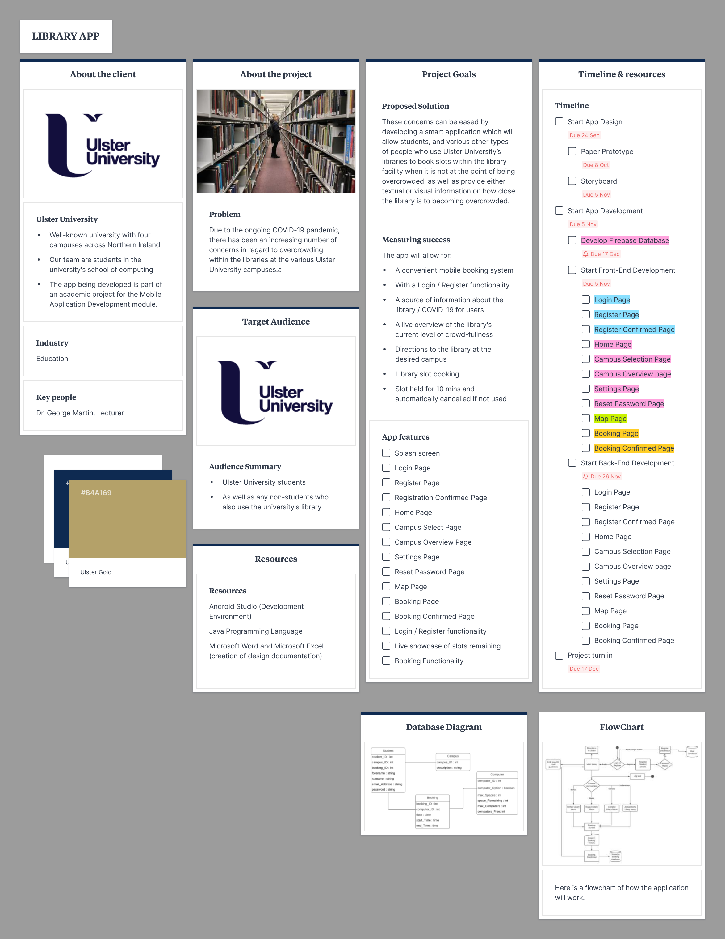

Figure - Application poster

# Design

Figure - User requirements

Upon starting the project, I was placed in charge of drawing up a list of basic requirements for the mobile application while my team members started to work on other aspects of design. After creating the list, I worked alongside my team to create a paper prototype and poster for the application. The User requirements that I drew up were then included in the application poster, as shown in figure 5.

# Developing a Firebase Realtime Database

My first role within this project was to develop a database that would connect to the application being developed, allowing that application to both read from the database, and write to the database.

The first thing I did was sign into the Firebase console using my Google account. I then created a new project and connected it to my Android Studio project for the application being developed. After that, I went to Realtime database within the Firebase console, I added the tables required for the application. These tables were Campus to store information on each separate library for each campus, as well as User for storing information on the application’s user accounts. After creating these tables, I added all the required fields alongside test data to be used within the application. Figure 6 shows the campus table within the Firebase console and Figure 7 shows the user table within the Firebase console.

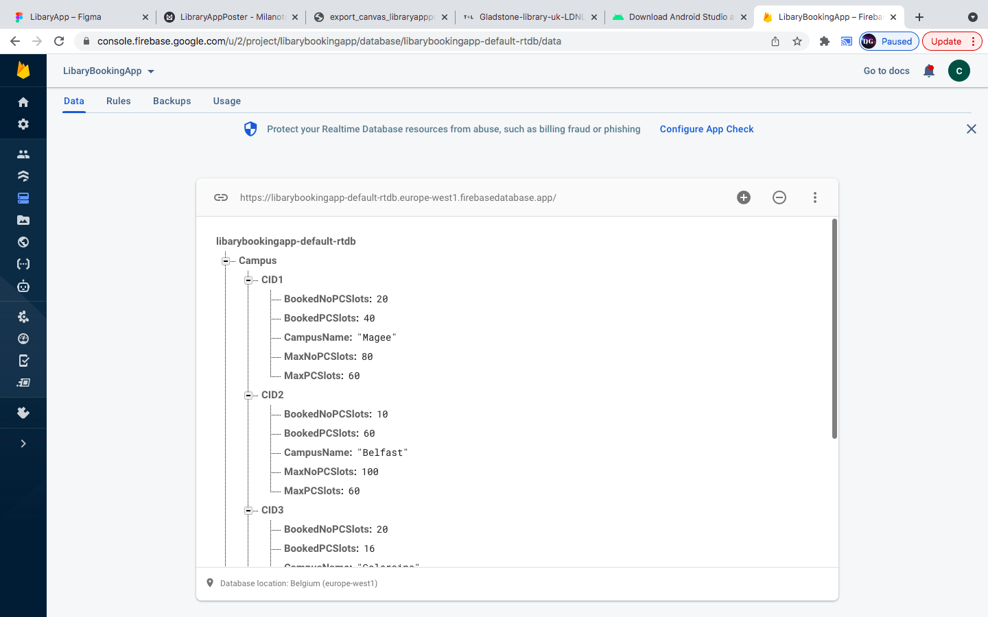

Figure - Campus table

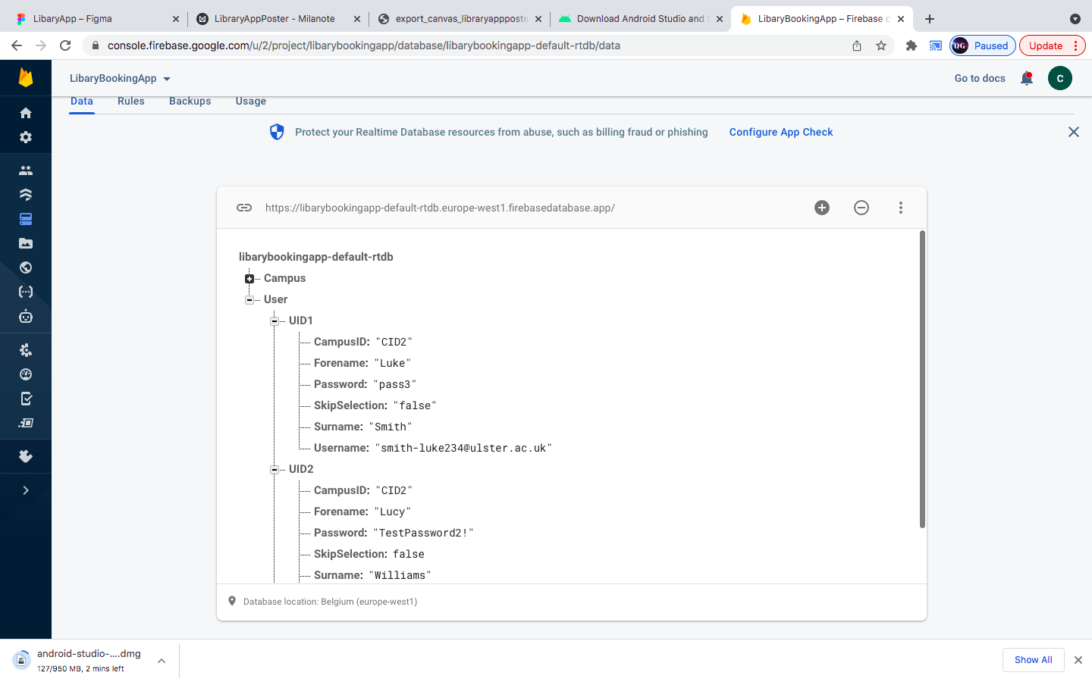

Figure - User table

To read and write to this database from within the application, I included a variable to hold an instance of the database, as well as a reference to the table that I want to use at the top of the code for every activity or page that reads and/or writes to the database. The code that does this is shown in figure 8.

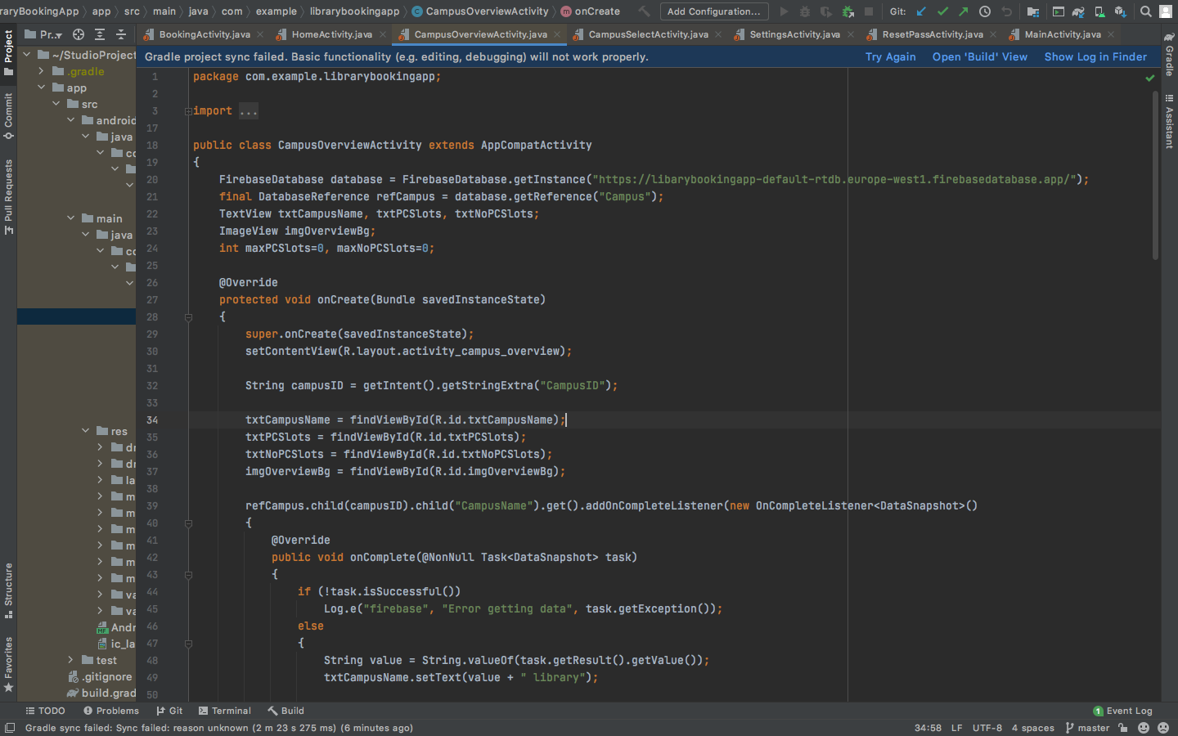

Figure - database and table referencing

To read from the database, I used the “addOnCompleteListener” as shown in figure 9, and to write to the database, I referenced a specific field within a table in the database and used the “setValue” method as shown in figure 10.

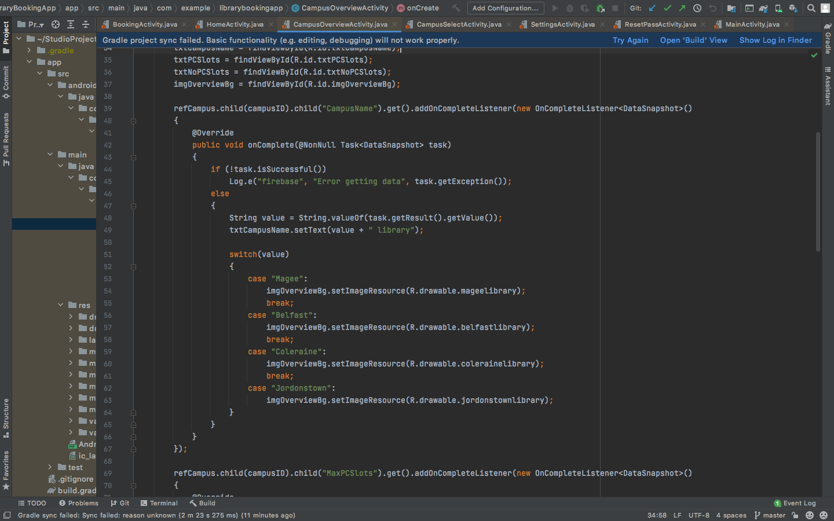

Figure – Reading from database

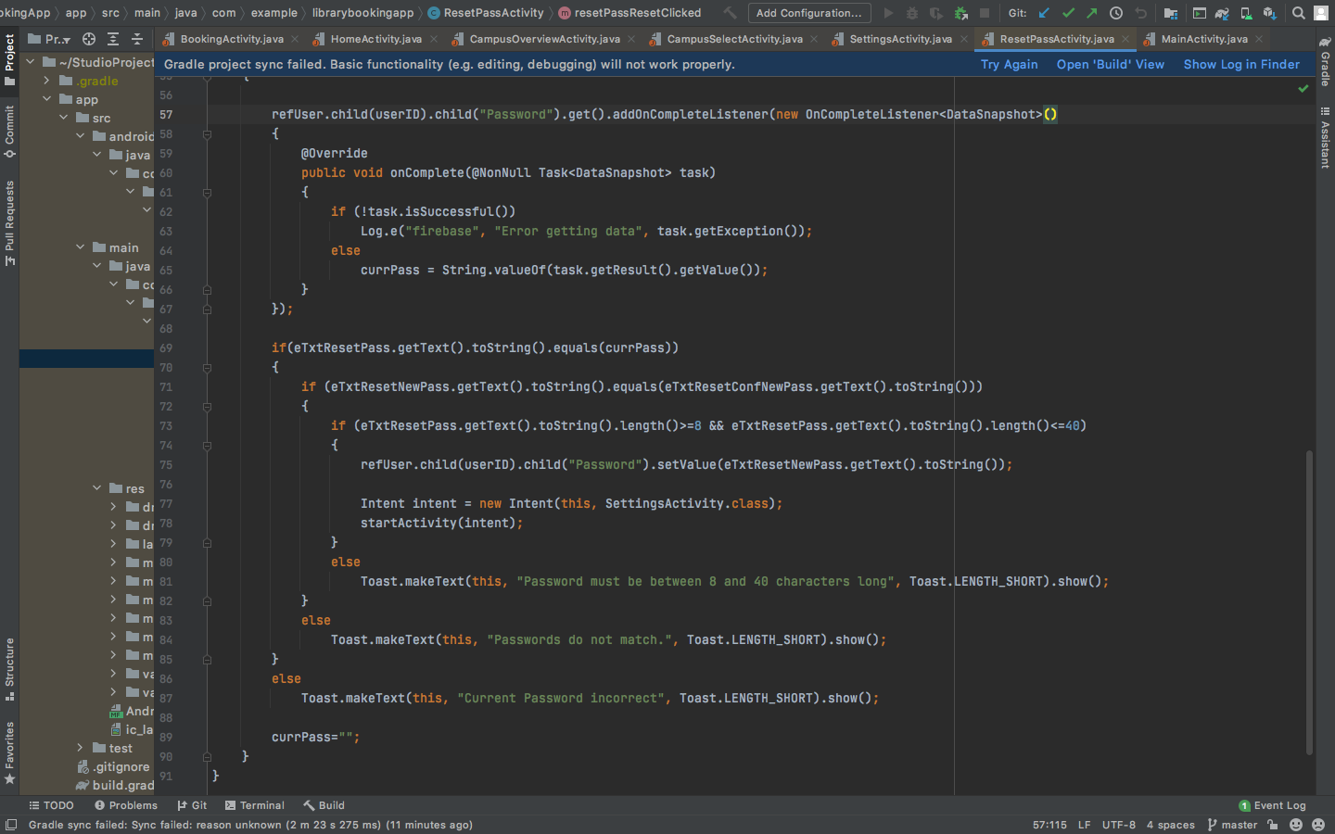

Figure - Writing to database

# Developing the Application

## Text Description automatically generatedHome Page

Figure - Home page

Throughout the course of the project, I developed five pages for the application. This included developing both the front-end and back-end of these pages. The first page that I developed was the Home page shown in figure 11. This page includes a few different interactive features for the user. The first label reads data from the Realtime database in order to welcome the correct user. The first button is an external web link which leads to the library web page on the Ulster University website, while the second button is an external web link which takes the user to an information web page on COVID-19 on the NHS website. The fourth button will take the user to the campus selection page if the user has checked the confirmation checkbox above it in advance. If the user does not check the checkbox, they will not be taken to the campus selection page. The user may also be skipped straight to the campus overview page if they changed their settings to make the application skip the campus selection page. The final button takes the user to the settings page.

The code that I wrote to create the home page is shown in figure 12. 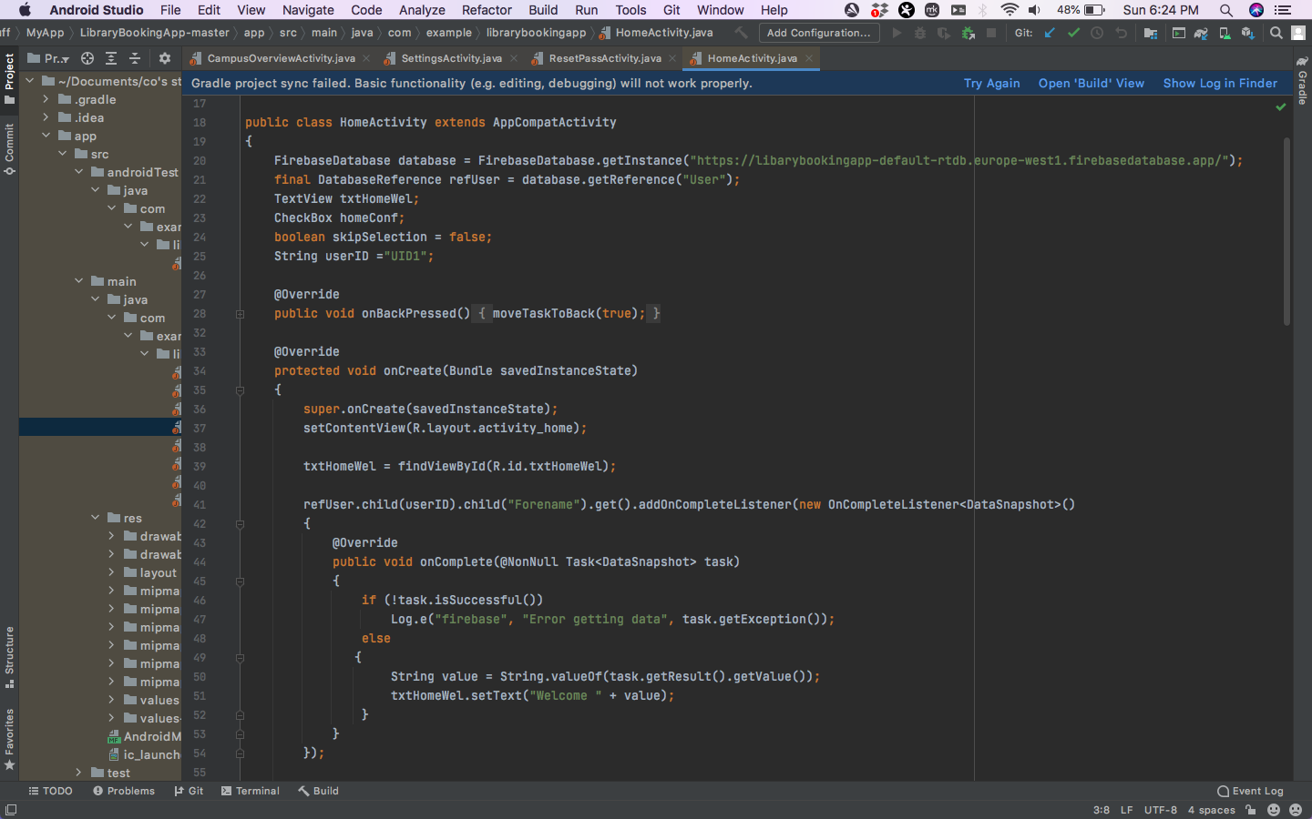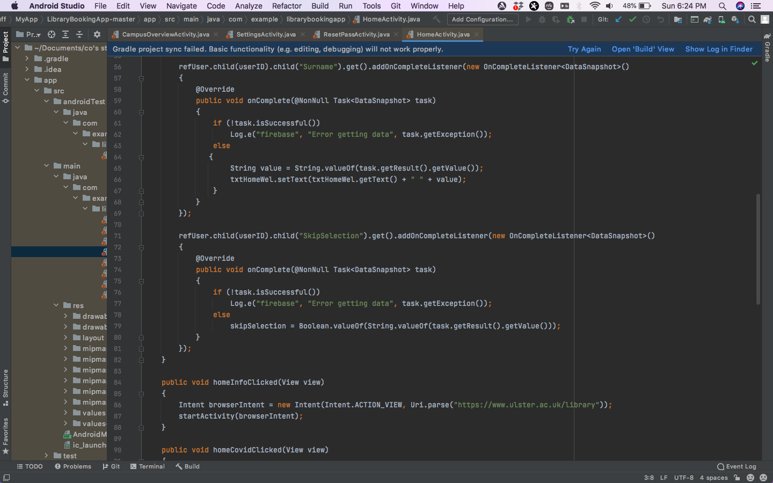

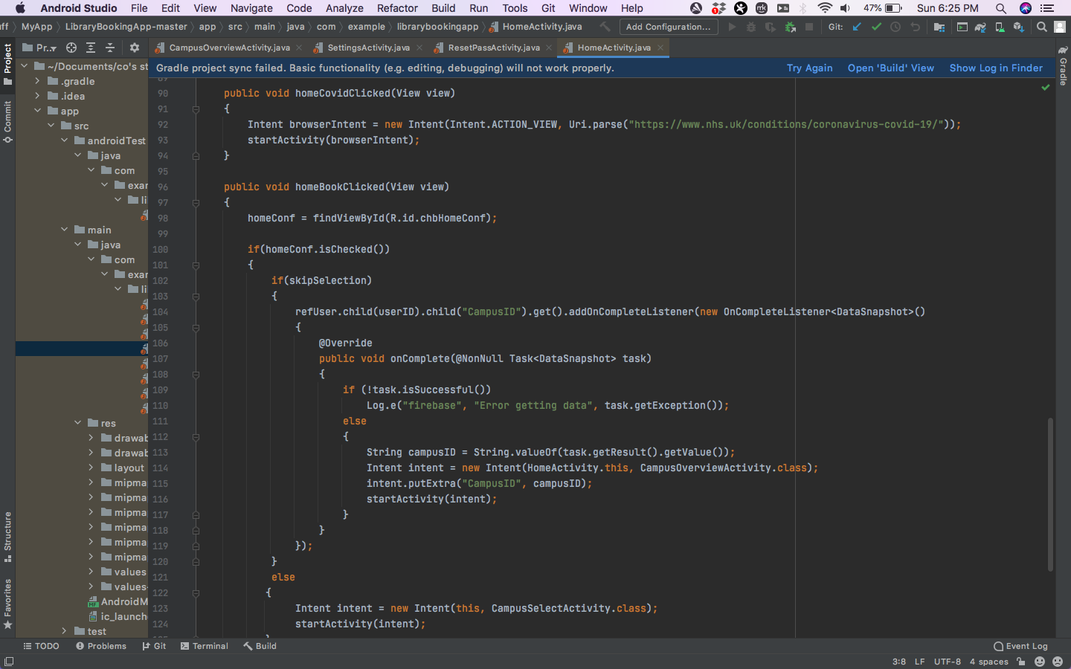

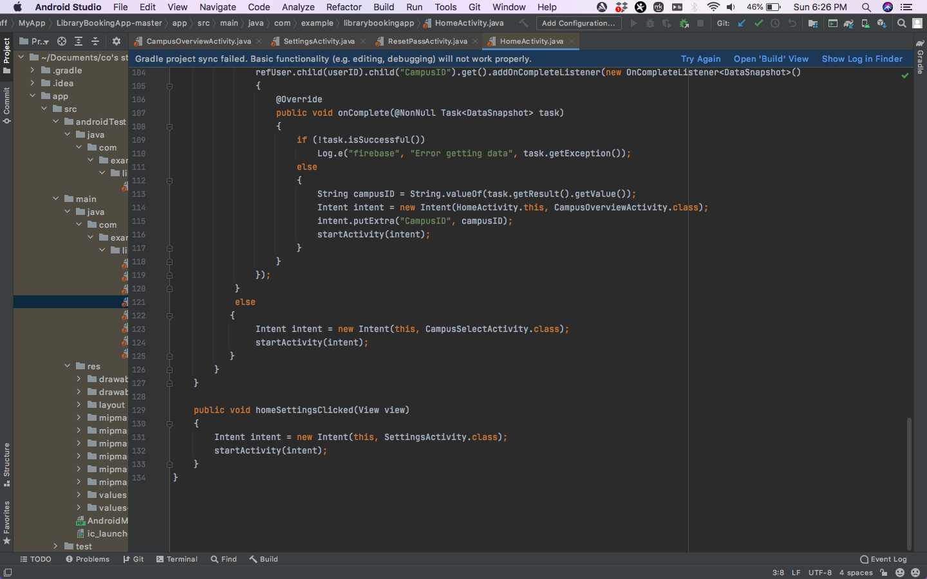

Figure - Home page code

## A collage of buildings Description automatically generated with low confidenceCampus Selection Page

Figure - Campus selection page

I developed a campus selection page which can be seen in figure 13 When the user accesses this page, they are presented with four options. Each option corresponds to a particular Ulster University campus. No matter which options the user select, they are taken to the campus overview page. However, the selection that the user makes changes the information that is presented on them in the campus overview page. For example, if the user selects the Magee campus option, they will be presented with an overview of the Magee campus on the next page.

The code that I wrote to create the campus selection page is shown in figure 14.

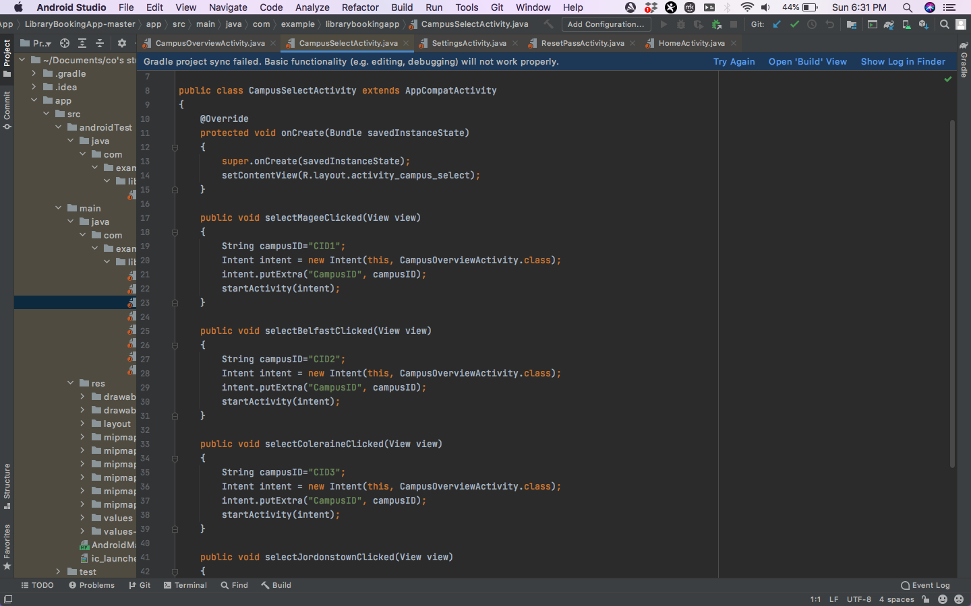

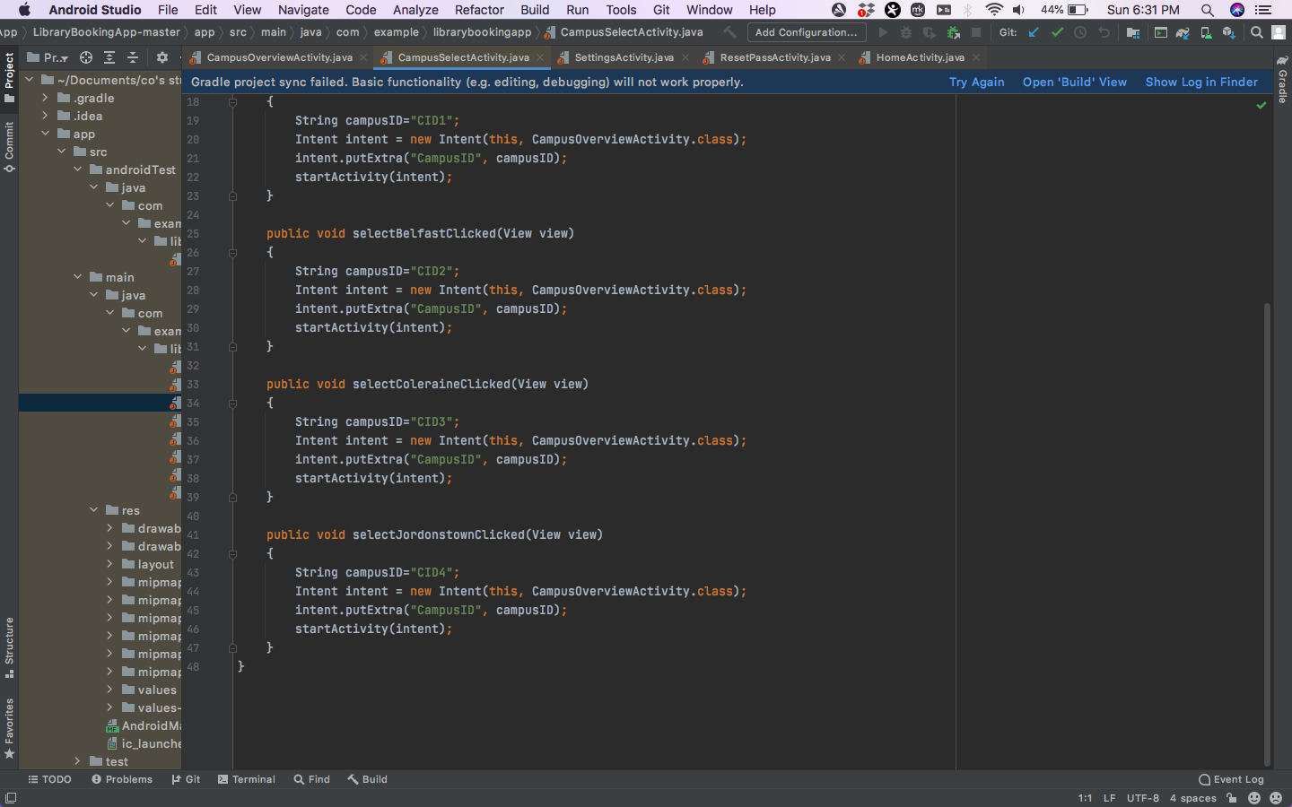

Figure - campus selection page code

## Campus Overview page

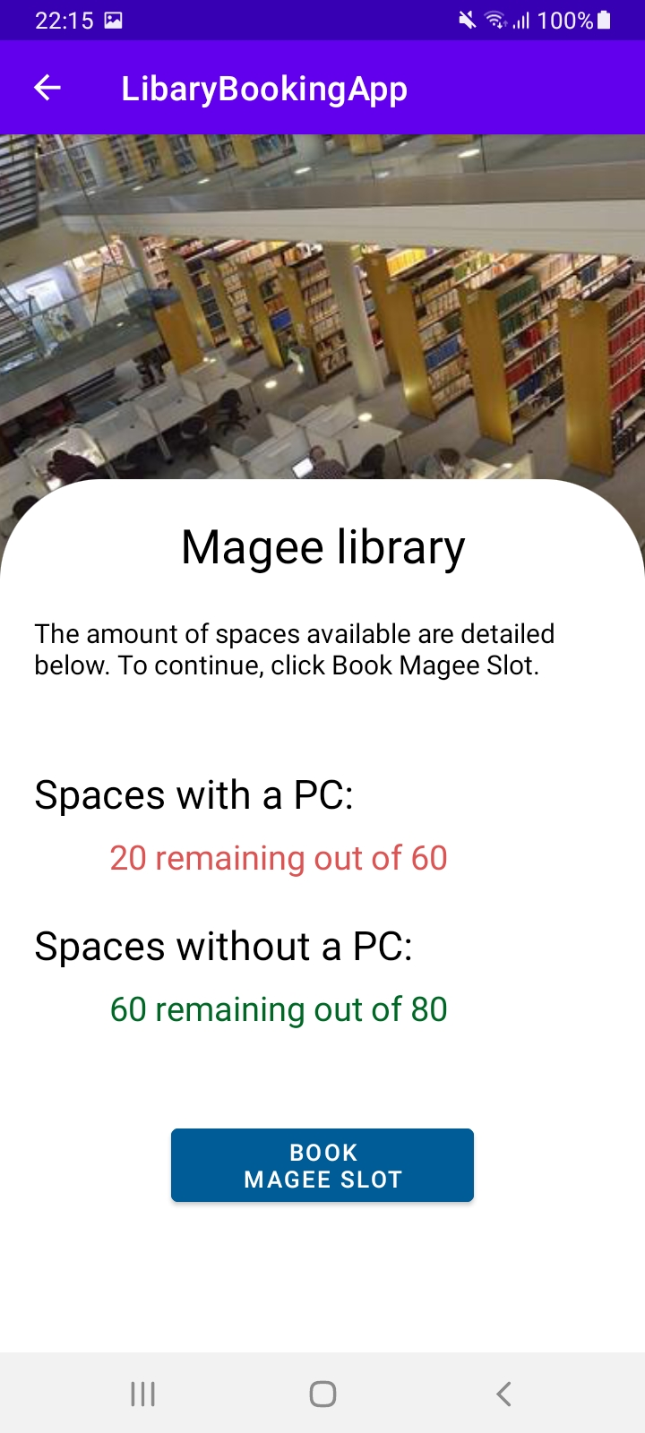

Figure - Campus overview (Magee)

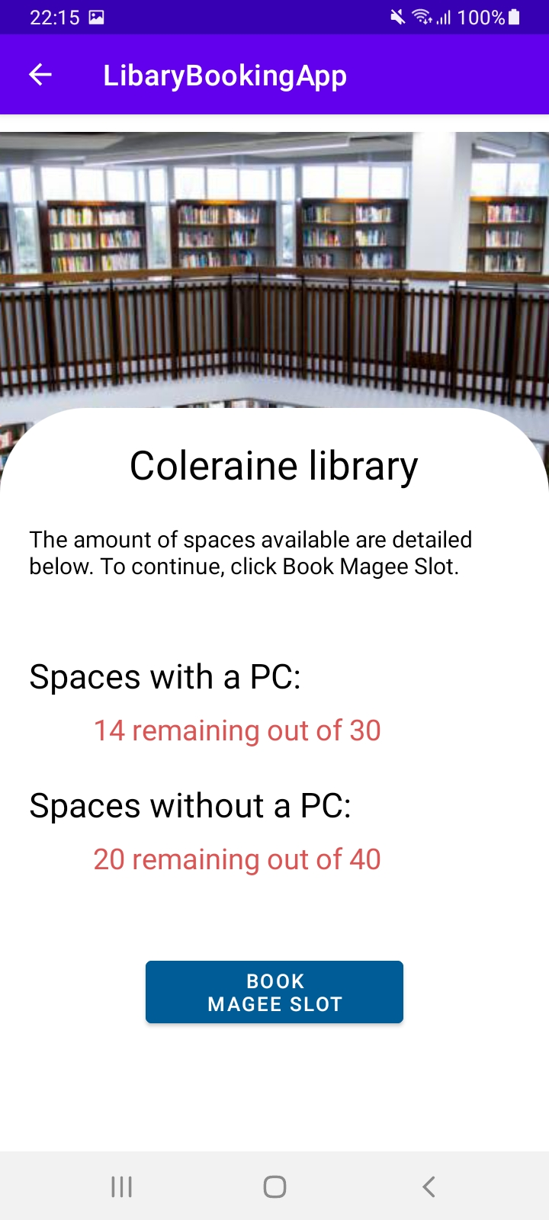

Figure - Campus Overview (Coleraine)

I developed a campus overview page. This page provides a live overview to the user. The information that it provides is dependent on the campus selection that the user made in the previous page. For reference of this, see figure 15 which is what the user sees when they access the campus overview page after selecting the Magee campus, and figure 16 which is what the user sees when they access the campus overview page after selecting the Coleraine campus. The background image and name of the library change in correspondence to this selection. As you can see, there is a live overview of the number of spaces left at the library. These spaces are categorized into either being a space with a PC, or a space without a PC. This overview is accurate because the application takes into consideration the campus selection that the user made and calculates the number of spaces remaining based on the max number of spaces, and the number of spaces currently based, which are both pieces of data held in the real-time database that I previously connected to the application. To provide further feedback to the user, the application changes the colour of the spaces remaining text. If there are less than 40 spaces remaining, the text colour is changed to red and if there are 40 or more spaces remaining, the text colour is changed to green.

If I had more time to improve this page, I would fix some minor problems with it. Firstly, I would make it so that the descriptive text underneath the campus title is more relevant to the user’s selection. See figure 12 where it says, “Book Magee Slot’. This is not relevant to the user in this scenario because they selected the Coleraine campus. I would then make the button more relevant to the user. See figure 12 again. The button says “Book Magee Slot” when it should say “Book Coleraine Slot”

The code that I wrote to create the campus overview page is shown in figure 17. 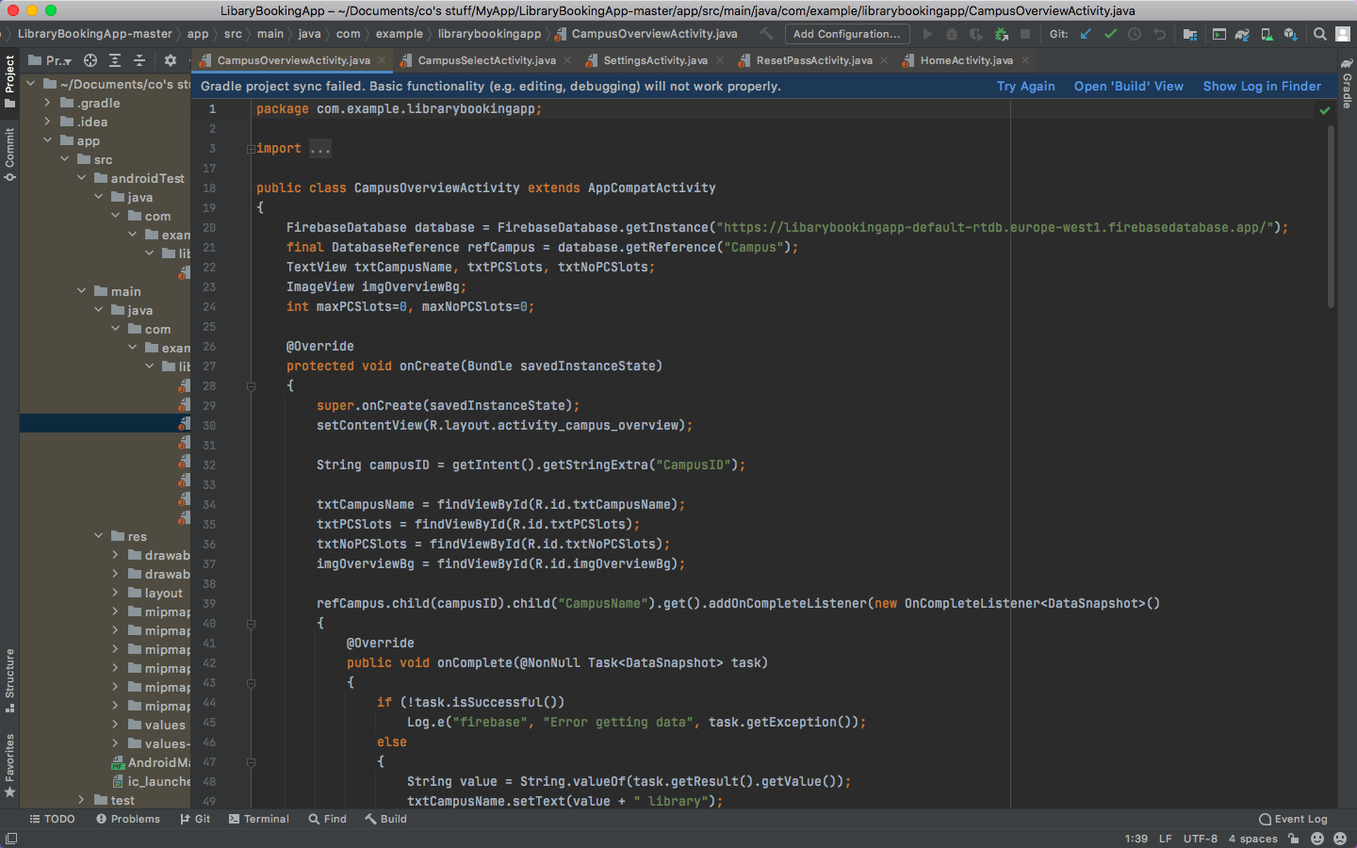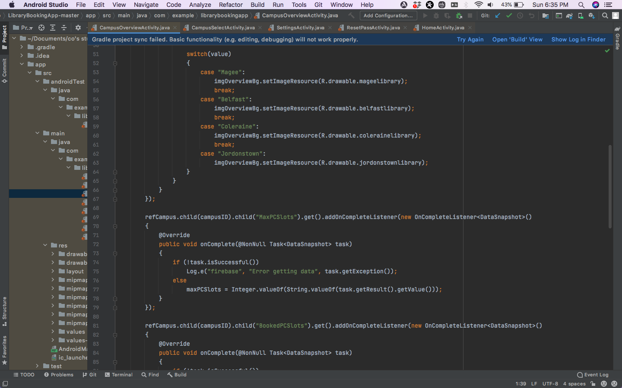

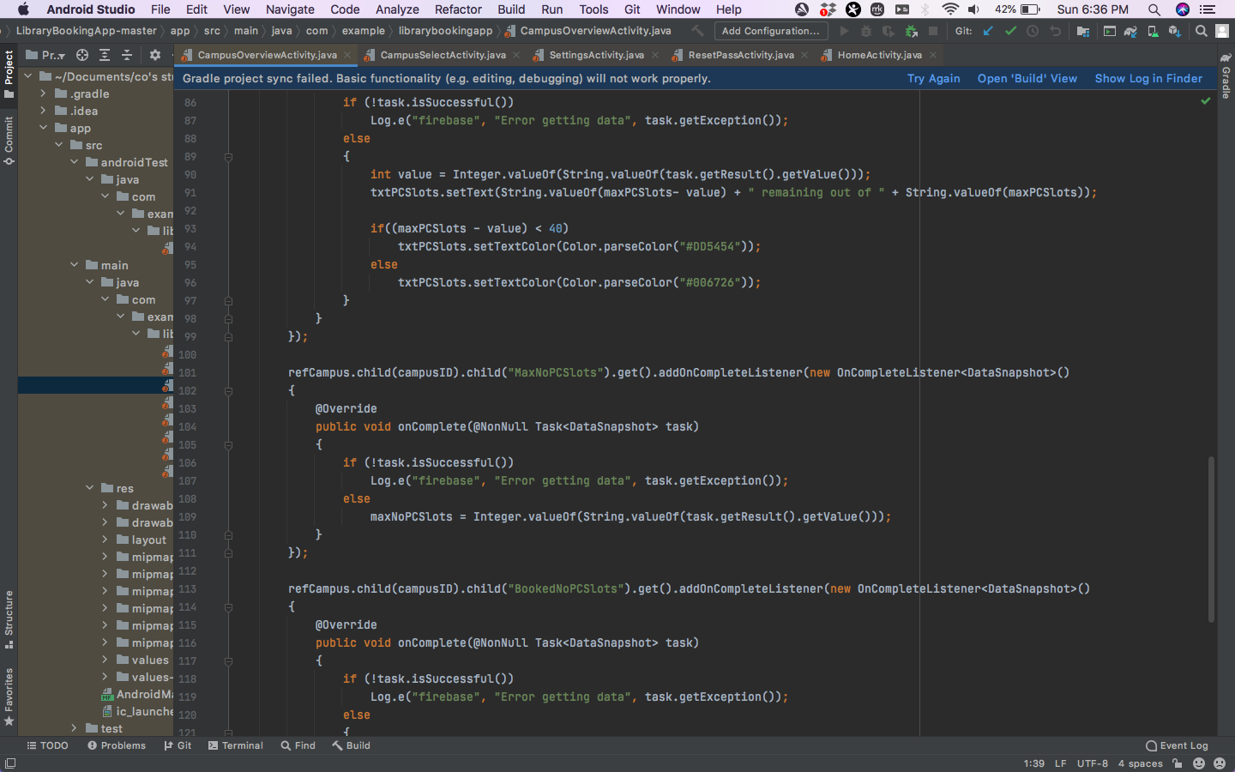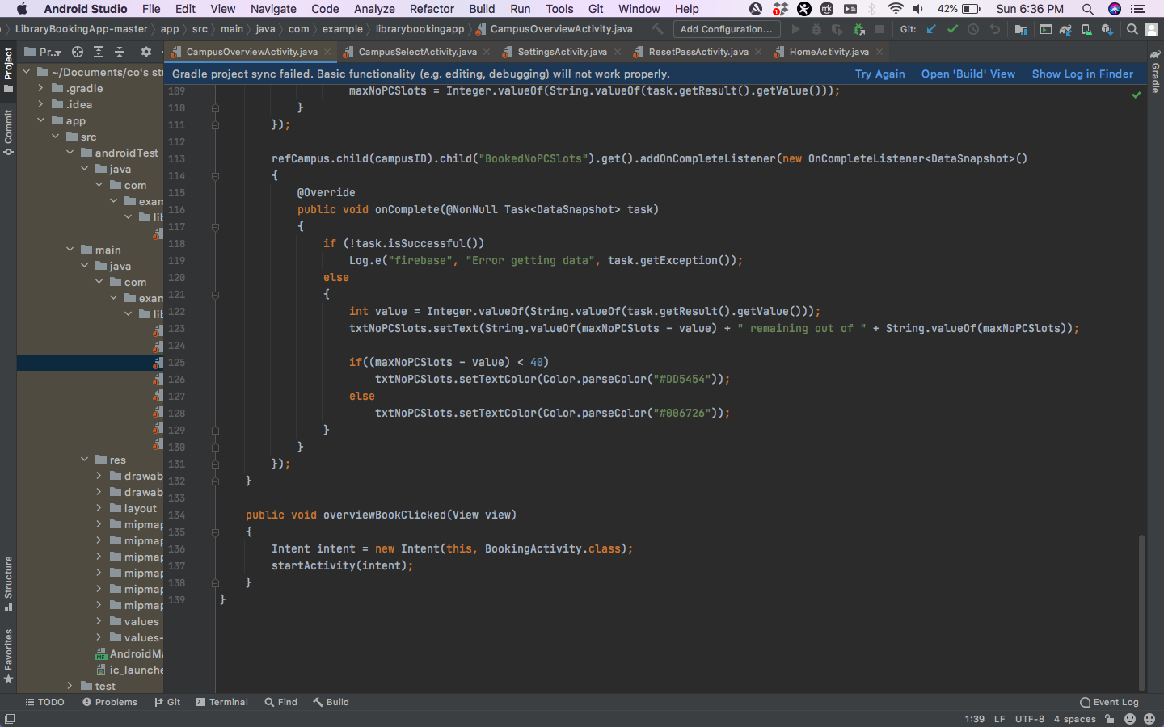

Figure - Campus overview code

## Graphical user interface, application, Teams Description automatically generatedSettings Page

Figure - Settings page

I developed a settings page which can be seen in figure 18. When the user accesses this page, details on the currently logged in user are read from the database and displayed to the screen. This includes their username and full name. This page presents the user with some options within the application. The first option is to change their default campus. There is a drop-down box that can be clicked on by the user, and then the different campuses are shown to the user. The user can then select one and the application will update the default campus field for the user within the Realtime database in correspondence with the selection that the user made. The user can also tick the skip selection checkbox, and doing so will update the real-time database, updating the skip selection field within the database to either true or false depending on whether the checkbox is ticked or not ticked. The reset password button takes the user to the reset password page where they can reset the password associated with their account. Ideally the “Log out” button would log out the currently logged in user and return them to the login page. However, I did not have enough time to add the back-end code behind this button to give it this functionality. The button is red to provide further feedback to the user by indicating that this button will perform a drastic action, i.e., log them out.

If I had more time to improve this page, I would finish adding all the required functionality for the page by adding the back-end code to the “Log out” button to create a functional log out button.

The code that I wrote to create the settings page is shown in figure 19.

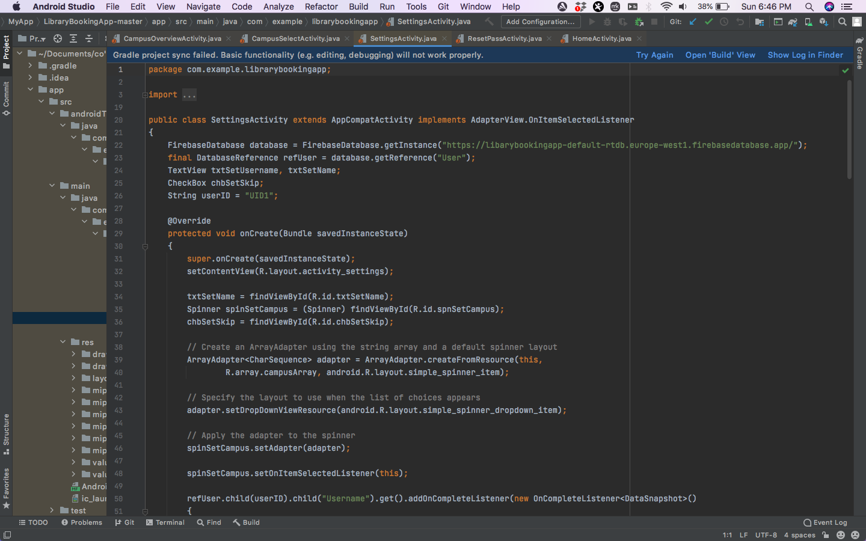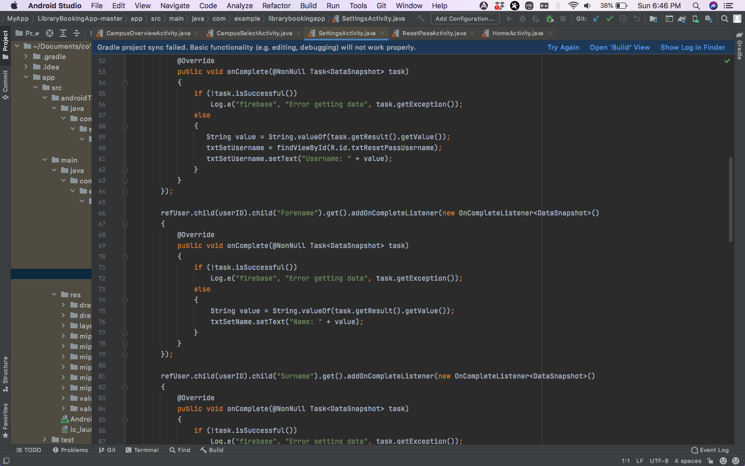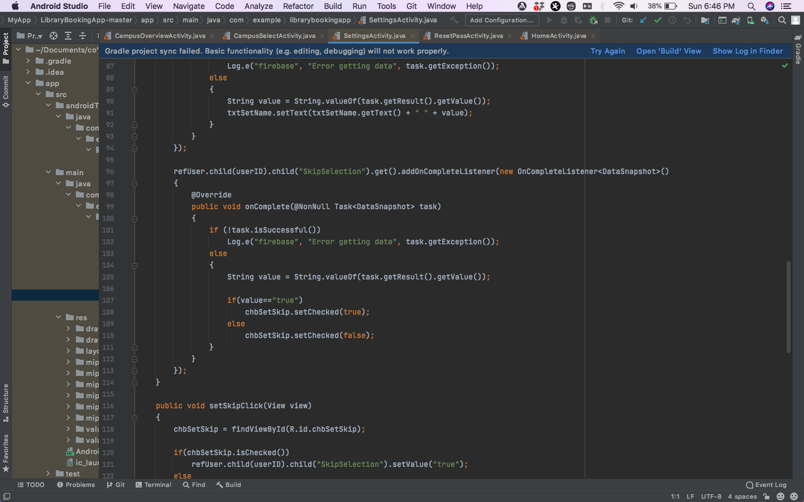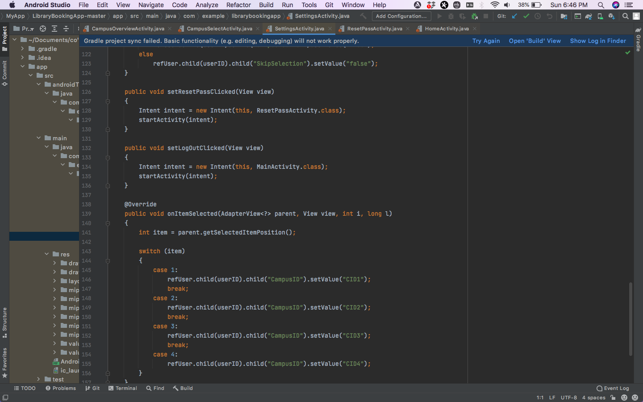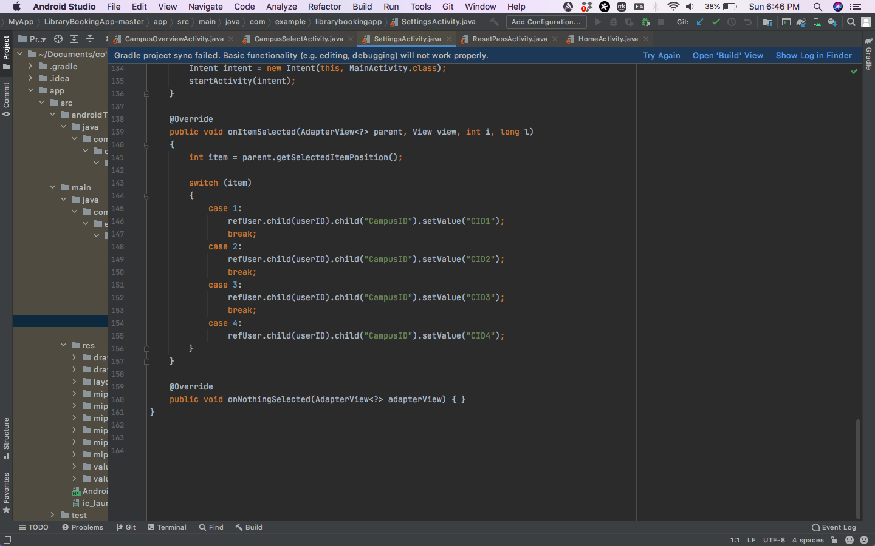

Figure -Settings page code

## Reset Password Page

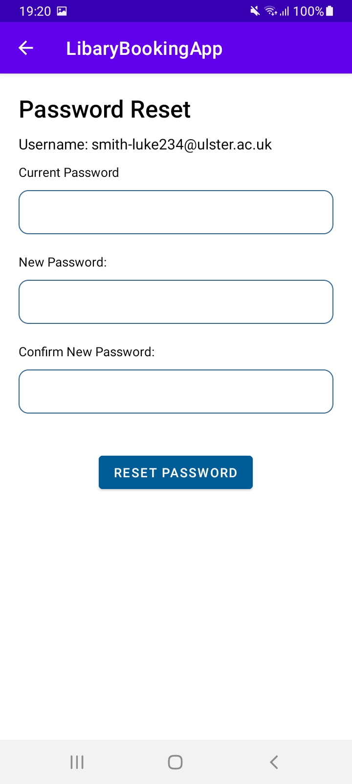

Figure - Reset password page

I developed a reset password page which can be seen in figure 20. When the user accesses this page, their username is read from the database and displayed below the page title. The user is then presented with three text boxes. The first text box requires the user to enter their current password. The second text box requires the user to enter their newly desired password and the third text box requires the user to enter to the new password again for verification purposes. The reset password button below these text boxes performs the password reset functionality. Upon the reset password button being clicked, the application checks if the text entered into the textbox labeled current password matches the password associated with the currently logged in user by reading their password from the database. If it does not match, an error message appears, and the user’s password does not change. If it does match, the application then checks if the two passwords entered into the last two text boxes are the same. If they are not, an error message appears, and the user’s password is not updated. If they do match, the application then checks if the password is valid by checking if it is between 8 and 40 characters long.

If I had more time to improve this page, I would add more validation checks for the new password such as checking if it included inappropriate symbols, ensuring that there were no spaces, ensuring that there were both alphabetic and numeric characters and at least one upper case character.

The code that I wrote to create the reset password page is shown in figure 21. 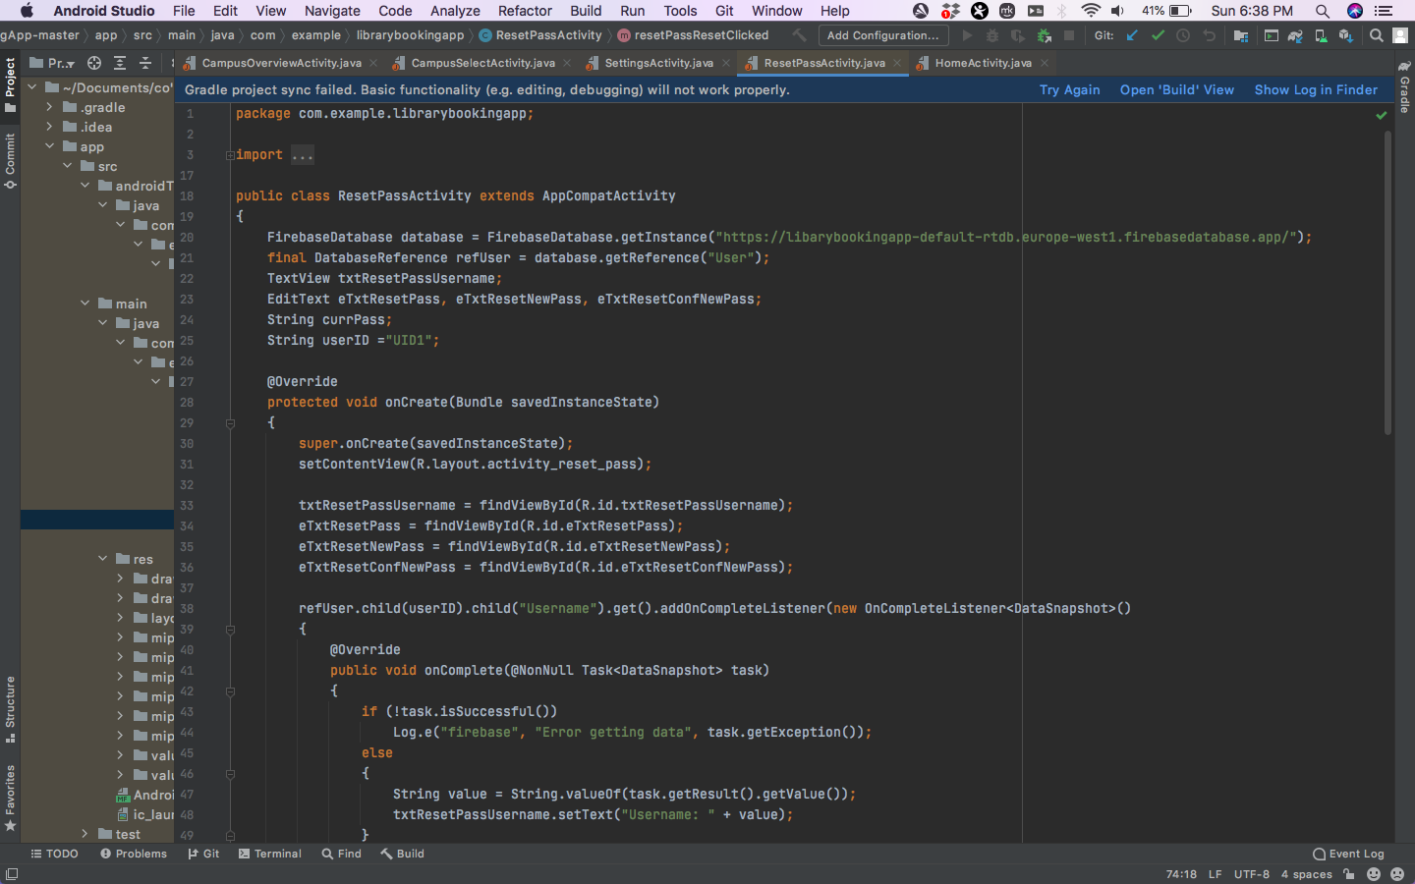

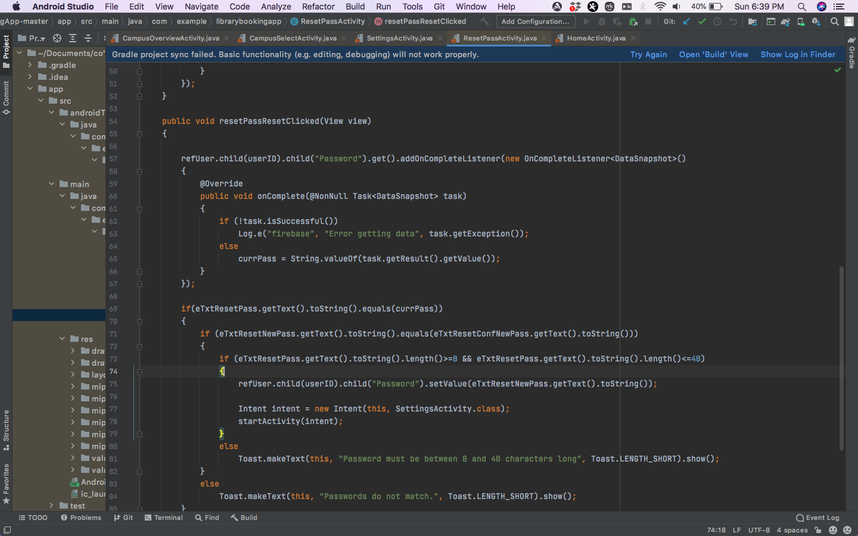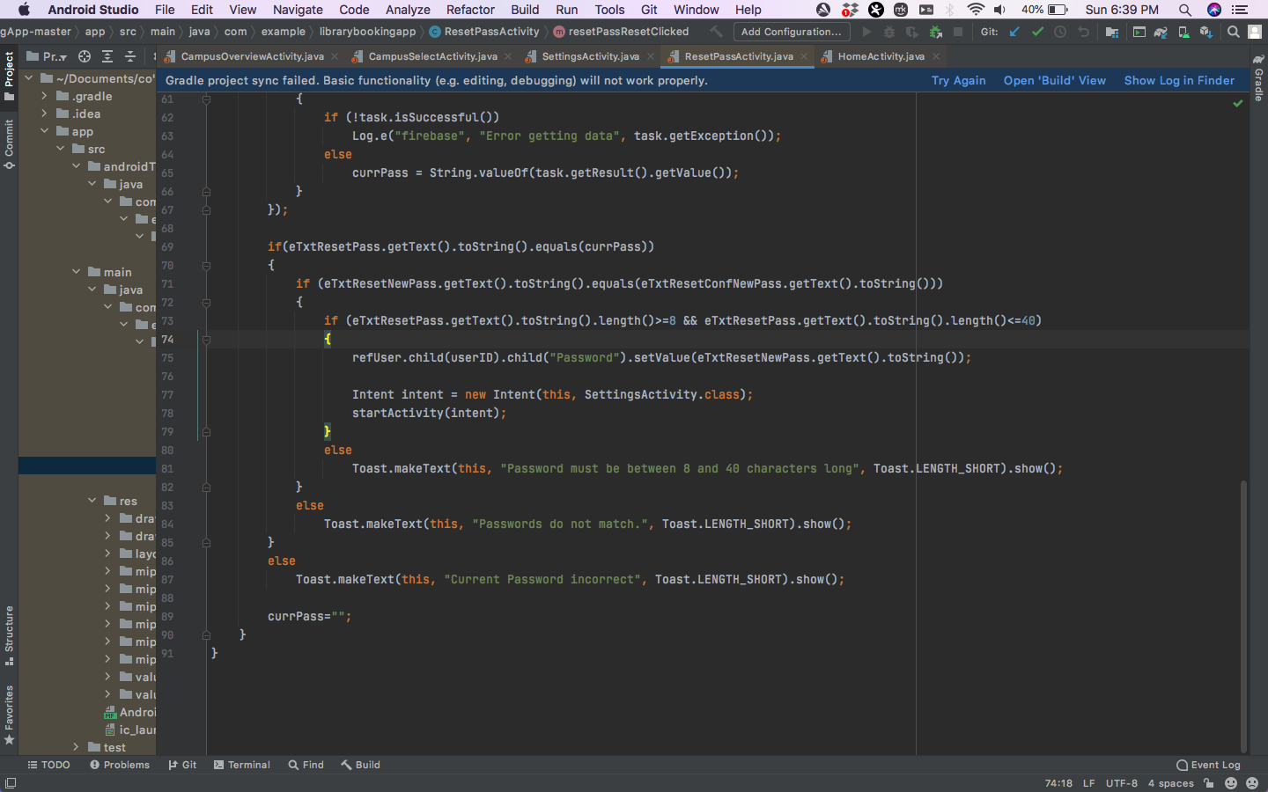

Figure - Reset password page code

## Splash Screen

 I developed a splash screen which can be seen in figure 22. This is seen by the user when they first open the application for a small amount of time, before it goes away, and the user is taken to the login page or ideally the home page if the user is already logged in.

Figure - Splash Screen